Purpose
ECG INTERPRETATION: PART I
This course prepares healthcare professional to identify and respond to abnormal ECG rhythms.

Objectives
At the completion of this course the participant will be able to:
1. | Describe the normal cardiac anatomy and physiology and normal electrical conduction through the heart.
2. | Identify and relate waveforms to the cardiac cycle.
3. | Understand the different lead placements and purpose of each placement.
4. | Utilize a systematic process when approaching the interpretation of the ECG.
5. | Identify normal and abnormal components on ECG.
6. | Recognize sinus, atrial, junctional and ventricular dysrhythmia on ECG and relate cause, significance, symptoms and treatment.
7. | Identify three pacemaker malfunctions.
The primary purpose of the cardiovascular system is to supply an adequate amount of blood to peripheral tissues to meet their metabolic demands at all times. The arterial system supplies tissues and organs throughout the body with oxygen, nutrients, hormones, and immunologic substances. Through venous return it removes wastes from tissues, routing deoxygenated blood through the lungs for excretion of metabolic wastes.
The heart is the size of a fist and as small as it is it carries an impressive workload over a lifetime. It beats 60 to 100 times per minutes without resting. The heart must be flexible and able to adjust to changes in the body's metabolic demands, often in a matter of seconds. Vigorous exercise can increase metabolic requirements of muscles as much as 20 times over their needs during rest. To meet these demands the heart accelerates it rate to increase cardiac output. Vessels must redistribute blood flow, shunting a greater proportion of blood to muscle tissues and away from internal organs.
The heart is unique and possesses several properties. It works as a pump by expanding and contracting without placing added stress on the cardiac muscle and without developing muscle fatigue. The heart pumps 4 to 8 liters per minute. This is equivalent to 6,000 liters per day. It has an inherent capability to generate electrical impulses that maintain proper rhythm regardless of other factors, such as heart rate, and ignores inappropriate electrical signals that might over stimulate the cardiac muscle.
The ECG is a valuable diagnostic tool for the healthcare provider whether they are a doctor, nurse, or specialist in cardiac rehabilitation. Understanding the ECG enables the healthcare provider to respond correctly and to treat dangerous and potential deadly arrhythmias as quickly and efficiently as possible. It is important to understand the mechanisms, cutting edge treatments and to know exactly what needs to be done to treat these deadly arrhythmias. New drugs and high tech equipment which can cardio-vert, defibrillate, and serve as a pace maker are constantly being evaluated and introduced into the healthcare system.

Anatomy and Physiology
The heart is a hollow, muscular organ located in the middle of the thoracic cavity, cradled in a cage of bone cartilage, and muscle. It lies left of the midline of the mediastinum and just above the diaphragm. The heart is protected anteriorly by the sternum and posteriorly by the spine. Lungs are located on either side. The entire heart is enclosed in the fluid-filled pericardial sac. This sac helps to shield the heart against infection and trauma, prevents friction, and aids cardiac function by helping with the free pumping action of the heart. The heart consists of three layers; Epicardium, Myocardium, and Endocardium.
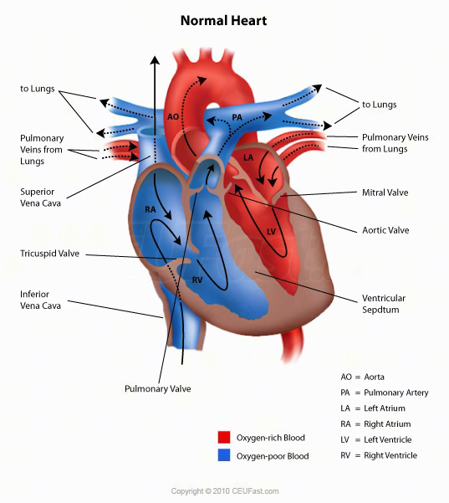

Function
Activities of the right side of the heart and the left side of the heart occur simultaneously.
The right side of the heart receives impure blood from the body via the vena cava into the right atria. Blood is ejected from the right atria into the right ventricle. Blood is pumped to the lungs from the right ventricle via the pulmonary artery. The left side of the heart receives oxygenated blood from the lungs via the pulmonary vein into the left Atria. Blood is ejected from the left atria to the left ventricle. Blood is pumped to the body from the left ventricle via the aorta. Briefly the Right side of the heart pumps blood into the lungs. The Left side pumps blood into the body.
The two atria and two ventricles of the heart are separated by atrioventricular valves. The action of the Right tricuspid and left Mitral (Diastole) represent the ventricle filing phase. AV-valves open during Systole; while the ventricle is in the contracting phase (empty) then the AV valves close. The Semilunar valves separate the ventricles from the arteries. The pulmonic valve separates the right ventricle, and the pulmonary artery. The Aortic valve separates the left ventricle from the Aorta, during systole, allowing blood to be ejected from the heart to the rest of the body.
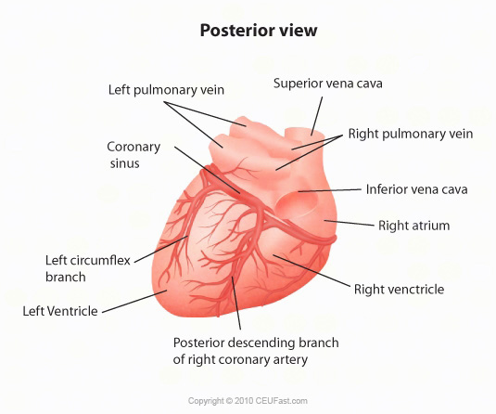

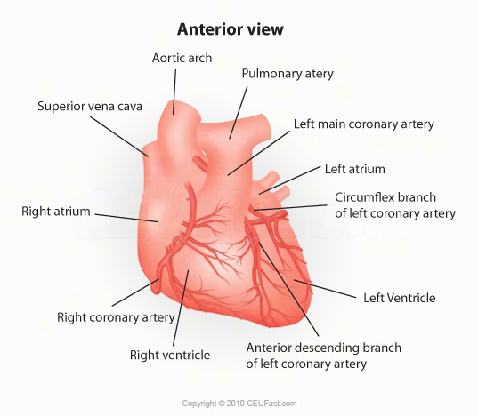

Coronary Arteries

Right Coronary Artery  Supplies: Right Atrium, Anterior Right  Posterior and Papillary Muscle Wall Ventricle  Posterior Aspect of Septum (90% of population)  Sinus and AV Nodes (80-90% of population)  Inferior aspect of Left Ventricle | Left Coronary Arteries  Left Anterior descending (LAD)  Supplies: Anterior Left Ventricular  Anterior Interventricular Septum  Septal branches supply conduction system, Bundle of HIS, and Bundle branches  Anterior papillary muscle  Left ventricular apex
Circumflex
Supplies: Left Atrium
Posterior surfaces of Left ventricle
Posterior aspect of septum

Electrical Activity of the Heart
The human heart is a remarkable organ. The human heart beats 80,000 to 100,000 times and pumps approximately 2,000 gallons a day. The heart will have beat 2-3 billion times and pumped 50-65 million gallons of blood over a 70-90 year lifespan. The human heart is made of specialized muscle capable of sustaining continuous beating. This muscle is different than skeletal muscle that powers the arms and legs. Specialized areas of the myocardium exert electrical control over the cardiac cycle. These areas exhibit physiologic differences from the rest of the myocardium, forming a pathway for electrical impulses which energize the heart muscle. The two types of cardiac cells are contractive and conductive. When the cells are at rest, they are electrically more negative on the inside with respect to the outside of the cell. Charged particles (ions) of sodium and potassium move in and out of the cell causing changes that are sensed by electrodes on the skin. The electrical action will show as a tracing on the ECG.
The sinoatrial (SA), or sinus node initiates a self-generating impulse and is the primary pacemaker which sets a rate of 60 to 100 beats per minute (bpm). The SA node is located at the border or junction of Superior Vena Cava and Right Atrium. Once generated, the electrical impulse sets the rhythm of contractions and travels through both atria over a specialized conduction network to the Atrioventricular (AV) Node. The AV node is located in the floor of the Right Atrium and receives the impulse and transmits to the Bundle of His. The Bundle of His then divides into a right bundle branch and two left bundle branches. These terminate in a complex network called the Purkinje Fibers, which spread throughout the ventricles. When the impulse reaches the ventricles, stimulation of the myocardium causes depolarization of the cells, and contraction occurs. The AV node serves as a gate to delay electrical conduction and in this way prevents an excessive number of atrial impulses from entering the ventricles.
The SA node and AV Nodes are supplied with sympathetic and parasympathetic fibers. This enables nearly instantaneous changes in the heart rate in response to physiologic changes in oxygen demand. The normal cardiac conduction system occurs in this sequence:
Sinoatrial node initiates electrical impulse and sends this impulse thru the atrium >lower section whereby an Atrial Kick occurs >AV node >Bundle of His thru ventricles via > Right Bundle & Left Bundle Branches>Purkinje fibers
If the SA node falters, a hierarchy of pacemakers are able to take over. Atrial, AV node, and ventricular escape pacemakers can function as subsidiary pacemakers, however they generated impulses at a much slower rates. The AV node generates rates between 40 to 60 bpm and the Purkinje fibers at 20 to 40 bpm.
Electrical impulse does not always equal contraction of the heart. Accessory pathways play a role in re-entry tachydysrhythmias, providing a detour for electrical impulses to circle through the heart.
Mahaim: Short, direct connections from the AV node (or the Bundle of His or bundle branches) to muscle fibers in the interventricular septum. Mahaim fiber conduction, a type of accessory AV conduction with abnormal beats originating below the region of normal delay in the AV-conducting system, causes an arrhythmia
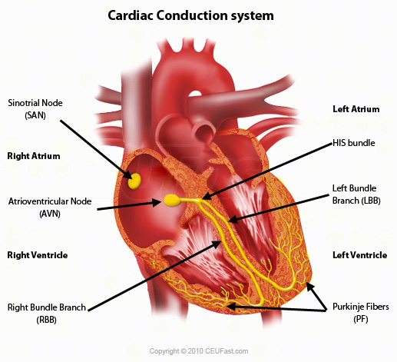

Components of the Electrical System

Sinoatrial node (SA Node) | Bundle of Kent | Bachman's Bundle | Atria Ventricles
Internodal Pathways | Bundle of Mahaim | Atrioventricular node (AV) | Bundle of His
Bundle of James | Right Bundle Branch | Left Anterior Fascicle | Right Posterior
Fascicle | Purkinje fibers | Accessory Pathways | AV node/His Atria
There are two myocardial cell types.
1. | Myocardial (working) cells (mechanical cells) which are located in the myocardium. These contain contractile filaments that contract when the cells are electrically stimulated. Their primary function is contraction and relaxation. Their primary property is contractility.
2. | Electrical cells (pacemaker cells). These electrical conduction cells are found in the electrical conduction system. They conduct impulses very rapidly and their primary property is automaticity and conductivity.
Electrophysiological Properties of a Cardiac Cell
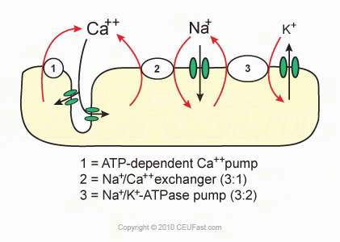

Cardiac cells are surrounded by and filled with a solution that contains ions. Three key ions are sodium (Na+), potassium (K+), and calcium (Ca++). In the resting period of the cell, the inside of the cell membrane is considered negatively charged and the outside of the cell membrane is positively charged. The movement of these ions inside and across the cell membrane constitutes a flow of electricity that generates the signal on an ECG.
Electrical Events of Depolarization and Repolarization
Polarized - Cardiac cells that are in a resting state are negative. The sodium ions are outside of the cell and the potassium ions are inside the cell. Both ions carry a positive charge however; the sodium ion has a stronger charge than the potassium. Thus the inside of the ion electrically is weaker than the outside so it is negative. The polarized state is a "ready state". When the cell is ready to accept and electrical impulse, a large amount of potassium leaks out. This causes a discharge of electricity. The cell becomes positively charged. This is called depolarization. The electrical wave then travels from cell to cell throughout the heart. Now there is cell recovery, sodium and potassium ions are shifted back to their original place by the sodium-potassium pump. This is called repolarization.
Action Potential of a Myocardial Working Cell
1. | Electrical impulses are the result of brief, but extremely rapid flow of positively charged ions (mainly Na+) back and forth across the cell membrane.
2. | Cardiac action potential illustrates the changes in the membrane potential of a cardiac cell during depolarization and repolarization.
There a five phases starting with the following:
Phase O Rapid Depolarization also called "upstroke", "overshoot", or "spike"
Begins when cell receives an impulse
Sodium moves quickly into the cell through the fast sodium channels
Potassium then leaves the cell
Calcium moves slowly into the cell through calcium channels
This is about +20 mV
Cell depolarizes and cardiac contraction begins
Phase 1 Early Repolarization
The Rapid flow of sodium into the cell is stopped as the fast sodium channels close
Potassium begins to reenter the cell and sodium begins to leave
This is about 0mV and is therefore neutrally charged, neither positively or negatively charged
This is the absolute refractory period
Phase 2 Plateau Phase (slow repolarization, part of absolute refractory period)
Slowly repolarization continues
Calcium continues to flow into the cell through slow calcium channels
Phase 3 Final Rapid Repolarization
Rapidly the cell completes repolarization
Calcium channels close
Potassium rapidly flows out of the cell
Active transport via the potassium-sodium pump begins restoring potassium to the inside of the cell and sodium to the outside of the cell
Cell now in negative state due to the outflow of potassium
Gradually the cell becomes very sensitive to external stimuli until its original sensitivity has been restored; called the relative refractory period.
Phase 4 Return to Resting Stage
Corresponds to diastole
Calcium and sodium remain outside the cell
Potassium remains inside the cell
During this phase the heart is "polarized" and getting ready for discharge
Once another stimuli occurs the cell will reactivate

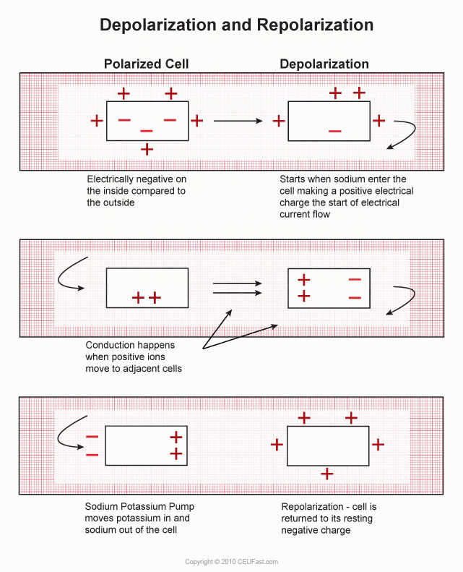

Depolarization Discharge, excited, active stage. Depolarization of the myofibril releases energy stored in the cell. This energy pulls the "contractile" proteins actin and myosin closer together, thus shortening the myofibril. This action immediately precedes mechanical systole.
Repolarization - Recharge, return to the resting stage. This is the longer portion of the action potential. Energy is reincorporated into the cell to restore the resting transmembane potential. Repolarization of the myofibril is the process that prepares the cell for another action potential and contraction and occurs during mechanical diastole.
Absolute Refractory Period During depolarization, the cell cannot accept another stimulus
Relative Refractory Period During repolarization the cell may be stimulated by only a strong stimulus
Keys to Remember:

1. Electrical events show as tracings on the ECG
2. Depolarization and Repolarization are Electrical Events
3. Contraction and Relaxation are Mechanical Events

Properties of the Heart
Automaticity is the ability of the heart to initiate an electrical impulse. The heart can begin and maintain rhythmic activity without the aid of the nervous system. A heart removed from the body has the ability to beat on its own for a limited period of time. The highest degree of automaticity is found in the pacemaker cells of the sinus node. The atria, atrioventricular (AV) Node, Bundle of His, bundle branches, Purkinje Fibers, and the ventricular myocardium have a lesser degree of automaticity.
Excitability is the ability of the heart to respond to an electrical impulse. A cardiac cell will respond to an electrical stimulus with an abrupt change in its electrical potential. Each cardiac cell that receives an electrical impulse will change its ionic composition and its respective polarity. Once an electrical potential begins in a cardiac cell it will continue until the entire cell is polarized.
Conductivity is the ability of the heart to conduct an electrical impulse. All areas of the heart appear to depolarize at the same time because a cardiac cell transfers an impulse to a neighboring cell very rapidly.
The velocity of the transfer varies in the different cardiac tissues:

200mm/second in the AV node
400mm/second in the ventricular muscle
1000mm/second in the atrial muscle
4000mm/second in the Purkinje fibers
Contractility is the ability of the heart to respond by contracting.

Conduction System
The normal cardiac impulse arises in the specialized pacemaker cells of the SA node, located about 1 mm beneath the right atrial epicardium at its junction with the superior vena cava. The impulse then spreads over the atrial myocardium to the left atrium via Bachmann's bundle and to the region of the AV node via the anterior, middle, and posterior internodal tracts connecting the sinus and AV nodes. These represent the usual routes of spread, but are not specialized tracts analogous to the Purkinje system. When the impulse reaches both atria, they depolarize electrically, producing a P wave on the electro cardiogram (ECG), and then contract mechanically, producing the A wave of the atrial pressure pulse and propelling blood forward into the ventricles.
Conduction slows when the impulse reaches the AV node, allowing sufficient time for blood to flow from the atria into the ventricles. After the impulse emerges from the AV node, conduction resumes it rapid velocity through the Bundle of HIS to the Right and Left Bundle Branches, and terminates in the Purkinje Fibers in the ventricular muscle.
Stimulation of the myocardium causes progressive contraction of the myocardial cells. Therefore, wave deflections correspond to the mechanical events in the cardiac cycle which include contraction and relaxation of the cardiac chambers. Repolarization is only electrical and the heart is at rest.
Three major waves of electric signals appear on the ECG. Each one shows a different part of the heartbeat.
The first wave is called the P wave. It records the electrical activity of the atria.
The second and largest wave, the QRS wave, records the electrical activity of the ventricles.
The third wave is the T wave. It records the heart's return to the resting state.

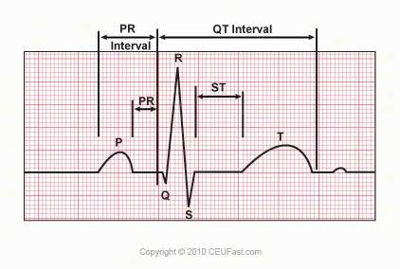

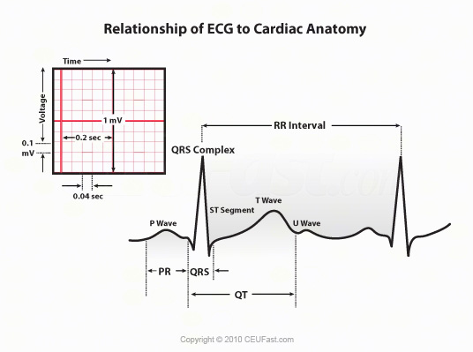

The P wave represents atrial activation; the PR interval is the time from onset of atrial activation to onset of ventricular activation. The QRS complex represents ventricular activation; the QRS duration is the duration of ventricular activation. The ST-T wave represents ventricular repolarization. The QT interval is the duration of ventricular activation and recovery. The U wave probably represents "after depolarization" in the ventricles.
Baseline is a bioelectric line; neutral usually without any deflections; flat line
"P" wave represents atrial depolarization. This represents one electrical activity associated with an impulse from the S-A node and its spread through the atria.
"P-R" Interval represents the time from the start of atrial depolarization, P-wave to the beginning of the QRS, or ventricular depolarization. Normal P-R interval is .12 to .20 seconds.
"QRS" represents ventricular depolarization (phase 0 of the action potential) until the end of ventricular depolarization. "Q" = initial downward or negative deflection
The normal Q wave is less than 25% of the amplitude of the R wave
The Q wave does not exceed 0.04 sec in duration
"R" = first upward or positive deflection after the P wave
"S" = first downward or negative deflection after the R wave
Normal QRS complex is 0.04 to 0.10 seconds in adults.
"ST segment" is the electrical resting period after ventricular depolarization. Represents early repolarization of the left and right ventricles. Begins with the end of the QRS complex and ends with the onset of the T wave. It is usually not depressed more than 0.5 mm in any lead.
"T Wave" ventricular repolarization and is not usually greater than 5 mm in amplitude. Peaked T waves are seen in hypercalcemia.
"QT" interval represents total ventricular activity which is the time required for ventricular depolarization and repolarization. Measured from the beginning of the QRS complex to the end of the T wave
Normally measures 0.36 -0.44 sec. This can vary with the patient's heart rate. Slower heart rates tend to have a longer QT interval and fast heart rates tend to have a shorter QT interval.
Prolonged QT intervals indicate a lengthened relative refractory period (vulnerable period). In the vulnerable period critical, life threatening rhythms may occur (Premature Ventricular Contractions Torsades de Pointe, "T" wave represents ventricular repolarization
Normally not greater than 5mm in amplitude
Peaked T waves are seen in patients with hyperkalemia

Determining Rate and Rhythm
Dr. Ken Grauer (2008) stresses that the real key to rhythm interpretation is to utilize a Systematic Approach.
1. | First ask yourself are there P waves?
2. | What is the QRS width?
3. | Is it a Regular rhythm?
4. | Are P waves related to the QRS?
5. | What is the Heart Rate?

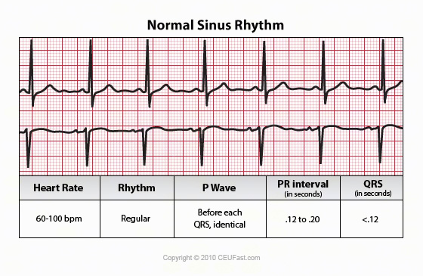

The Graphing Paper

The horizontal lines measure time
Vertical lines measure amplitude of voltage
Records at 25mm/sec
Width of each small square = 0.04 seconds
Width of one large square = 0.20 seconds
Five large boxes = one second
One large box = 5 mm high = 0.5 millivolts

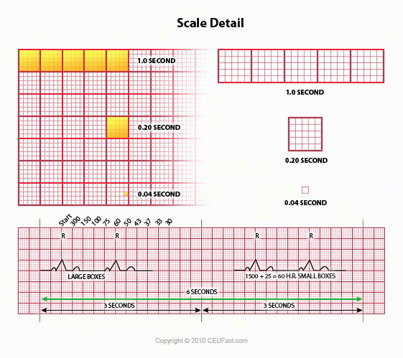

Calculating the Heart Rate
There are several methods for calculating the heart rate.
1. | Rule of 300: If the rhythm is regular, the heart rate can be "estimated" by using the "Rule of 300". Count the number of large squares between two R waves and divide this number into 300. ( There are 300 boxes, or 1500 tiny boxes, in a one minute strip)
2. | The Six-Second Method: Count the number of complete R waves within a period of 6 seconds and multiply that number by 10. This is the one minute heart rate. This method can be used when the rhythm is "regular or irregular".
3. | The Three-Second Method: Count the number of complete QRS complexes in a period of three seconds and multiply that by twenty. This is the one minute heart rate.
4. | The Block Method: Find a QRS complex that hits exactly on a vertical line.

 | The next block | 300
 | The second block | 150
 | The third block | 100
 | The fourth block | 75
 | The fifth block | 60
 | The sixth block | 50
 | The seventh block | 43
 | The eight block | 37
 | The ninth block | 30
 | The tenth block | prayers are needed

Analyzing a Rhythm Strip Using the Eight Step Approach
Step One: Determine the Rate:
What is the atrial rate?
To determine the atrial rate, measure the distance between P-P.
What is the ventricular rate?
To determine the ventricular rate, measure the distance between R-R.
Note: The rate of a Normal Sinus Rhythm is 60-100 beats per minute
Step Two: Determine the Rhythm
Is the rhythm is regular or irregular?
To determine if the atrial rate is regular or irregular, measure the distance between two consecutive P-P intervals. Use a point from one P wave to the same point on the next P wave. Then compare this with another P-P interval. If the atrial rate is regular, the P-P interval will measure the same.
Determine if the ventricular rate is regular or irregular, measure the distance between two consecutive R-R intervals Use a point from one R wave to the same point on the next R wave. Then compare this with another R-R interval. If the atrial rate is regular, the R-R interval will measure the same.
Is the rhythm regular? Basically regular? Regularly irregular? Irregularly irregular?
Step Three: Evaluate P Waves
Are P waves present and uniform in appearance?
Are P waves upright (positive) in Lead II?
Do P waves appear regularly before each QRS complex or is there
More than one P wave before a QRS complex?
If irregular is there an associated beat?
Step Four: Evaluate the P-R interval
If the P-R interval is less than 0.12 or more than 0.20 second, conduction follows an abnormal pathway or the electrical impulse was delayed at the AV node.
The normal P-R interval is 0.12 to 0.20 second.
Is the P-R interval consistent?
Step Five: Evaluate the QRS complex
Do the QRS complexes occur uniformly and look the same throughout the strip?
If the QRS measures .10 second or less it is considered narrow and is presumed to be supraventricular in origin.
If the QRS complex is greater than .12 second or more it is considered wide, and presumed to be ventricular in origin until proven otherwise.
The QRS normally measures 0.04 to 0.10 seconds in duration. Determine if they are married to the P waves.
Step Six: Evaluate T Wave
Are T waves present?
Are T waves smooth and rounded?
Do they have normal amplitude of 0.5 mV or less?
Is the deflection the same as the preceding QRS?
Is there a relationship between any ectopy to the T wave?
Step Seven: Evaluate the QT Interval
Is the duration from 0.36 to 0.44 seconds?
Step Eight: Evaluate other components
Is the ST segment elevated? Depressed? Sloping or scooped?
Are U waves present? Prominent?
Are there other (funny little beats) FLB's detected?

Naming the Rhythm
Origin of the Impulse plus the Cardiac Activity = rhythm name.
Origin of the Impulse: Is it sinus, atrial, junctional, or ventricular?
Cardiac Activity: Normal (In rhythm), bradycardic (slow), accelerated (Faster than normal), or Tachycardic (Greater than 100/min)?
For example: sinus bradycardia, sinus tachycardia, accelerated junctional, or ventricular tachycardia.

Escape Pacemakers
The normal electrical flow through the heart originates in the SA node>AV node>Bundle of His> left and right bundle branches> Purkinje fibers where the mechanical cells are stimulated. The primary pacemaker therefore is the SA node and has an inherent rate of 60-100 beats/minute. The SA node has the highest level of automaticity, but escape pacemakers can exist.
Common escape pacemakers exist in the Atrio-Ventricular (AV) junction and in the Ventricles.
The AV junction is the AV node and the nonbranching portion of the Bundle of His. The pacemaker cells in the AV junction are located near the nonbranching portion of the Bundle of His.
The AV node only generates an impulse if the SA node does not function at its normal rate. The AV node fires electrical impulses at a rate of 40-60 beats/ minute.
The Ventricular pacemakers located in the bundle branches and the Purkinje network will become the initiating pacemaker if the AV node is not able to function at its normal rate. The inherent ventricular rate is 20-40 beats/minute.

Reentry
This occurs when an electrical impulse is delayed, blocked or both in one or more portions of the electrical conduction system while the impulse is conducted normally through the rest of the conduction system. The end results are a delayed impulse entering cardiac cells which have been depolarized by the normally conducted impulse. If they have repolarized sufficiently, depolarizing them prematurely, produces ectopic beats and rhythms.

Lead Placement

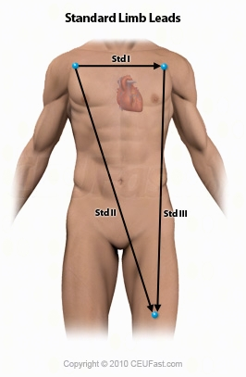

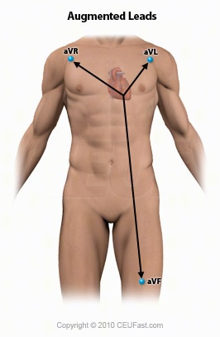

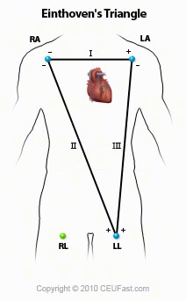

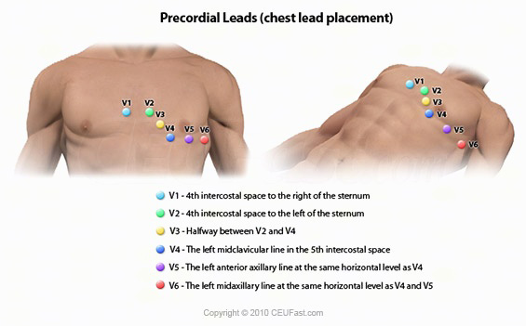

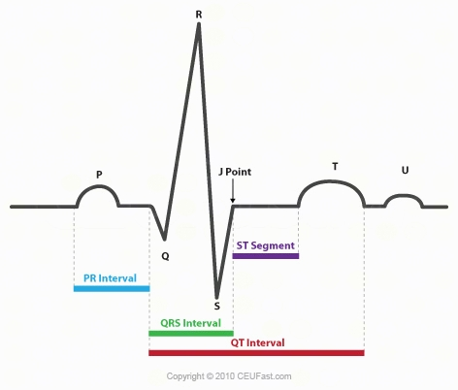

Lead I:
Positive electrode is placed just below the left clavicle
Negative electrode place just below the right clavicle
Provides information about the left lateral wall of chest.
Lead II:
Positive electrode just below the left pectoral muscle
Negative electrode just below the right clavicle
Provides information about the inferior wall of the heart
Very common in cardiac monitoring because position of this lead is close to actual conduction pathways.
Lead III:
Positive electrode is at the left pectoral muscle, and negative is below the left clavicle.
Provides information about the inferior wall of the heart
MCL I
Negative electrode is below the left clavicle and positive is at the right of the sternum at the fourth intercostals space.
Useful in assessing the anterior wall of the heart (LV) and the conduction through the ventricles.
This lead is useful in assessing the width of the QRS complex to differentiate supraventricular tachycardia (SVT) from ventricular tachycardia (VT).
Disorders of the Heartbeat are caused by:
1. | Defects in impulse formation
2. | Defects in impulse conduction
3. | Combinations of above
Arrhythmogenic Mechanisms
Reentry
Altered automaticity- enhanced or depressed
Normal Sinus Rhythm

Sinus Bradycardia
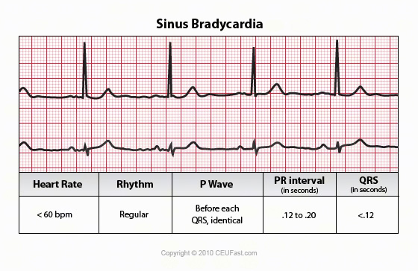

May be due to: a normal response to sleep or in well conditioned athlete, abnormal drops in rate could be caused by diminished blood flow to S-A node, vagal stimulation, hypothyroidism, increased intracranial pressure, or pharmacologic agents, such as digoxin, propranolol, quinidine, or procainamide.

Author: Donna Thomas, RN, BSHEd
Donna Thomas, RN, BSHEd, a hospital supervisor with over 37 years of teaching experience, coordinates ACLS, BCLS, AIDS/HIV, Disaster Planning, Leadership, Management, Critical Care classes, former Medical Explorer Leader/Advisor for High School Students and former Water Safety Instructor Trainer for the American Red Cross.

