ECG INTERPRETATION: PART III

Pacemakers
The following are indications for a Pacemaker:
Symptomatic Sinus Bradycardia
2:1 AVB
Junctional rhythms
Idioventricular rhythms
Dying heart
Asystole
Overdrive suppression of tachycardias
Second degree AVB Type II
Third degree AVB
Pacemaker Terminology
Firing refers to the pacemaker's generation of electrical stimuli. This is seen as a pacemaker spike on the ECG.
Capture refers to the presence of a P or QRS or both after a pacemaker spike. This indicates that the tissue in the chamber being paced has been depolarized. The term is that the pacemaker has "captured" the chamber being paced. Paced QRS are wide, bizarre and resemble PVCs.
Sensing refers to the pacemaker's ability to recognize the patient's own intrinsic rhythm in order to determine if it needs to fire. Most pacemakers function in the demand mode and fire when needed.
Pacemaker Malfunctions
Failure to Fire: When a pacemaker fails to send an impulse when it should it is said to malfunction. Usually this means a dead battery or that the connecting wires are at fault. At time artifact can fool the pacemaker and it will not fire. This is displayed as no pacer spike where there should be one.
Loss of Capture: When loss of capture exists there is no P or QRS after the pacer has fired; just a spike. The pacer needs to be adjusted to allow detection of the heart's need to be paced. It is possible the pacing wire has lost contact with the chamber wall which can occur when the heart is too damaged to respond.
Under-sensing: This occurs when the pacemaker fires too soon after an intrinsic beat and there are pacer spikes where there should not be. These can appear in the T wave, on the QRS or anywhere on the heart rhythm's tracing. This requires adjustment with the wires or battery replacement.
Assessing Pacemaker Function
Classification:
Pacemaker function is usually identified by 3 letters which indicate the cardiac chambers paced, sensed, and the mode of pacing.
First letter (A, V or D) refers to the chamber(s) paced (Atria, Ventricles, Dual both atria and ventricles).
Second letter (A, V or D) refers to the chamber(s) sensed (Atria, Ventricles, Dual both the atria and ventricles).
Third letter mode of pacing (Inhibited or Triggered or Demand).
Examples: DDD, VVI, VVD
Pacemaker function is judged by its ability to Sense the patient's underlying rhythm and Pace or Capture the ventricles when needed. Capture is confirmed when a QRS complex follows a Pacemaker Spike. (A Spike is a vertical line on the ECG which indicates the pacemaker has fired. A QRS after a spike means there is ventricular capture).
Three questions to ask when analyzing an ECG strip with pacemaker spikes are:
1. | Is the chamber being paced capturing?
2. | Is the pacemaker sensing the patient's inherent rhythm?
3. | Is there a pulse with each the pacer rhythm?

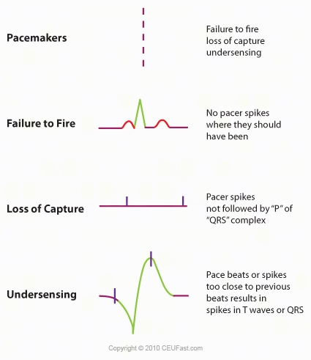

Diagrams of C Rhythms
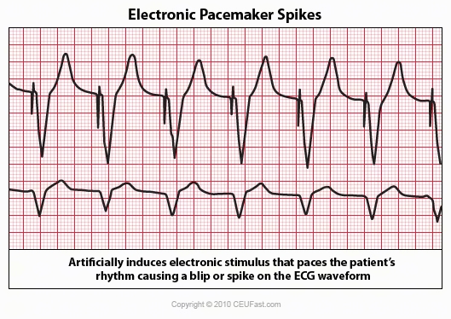

Ventricular Pacemaker
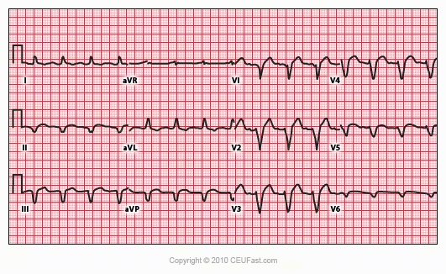

Observe the small pacemaker spikes before the QRS complexes in many of the leads. In addition, the QRS complex in V1 exhibits ventricular ectopic morphology. There is a slur or notch at the beginning of the S wave.
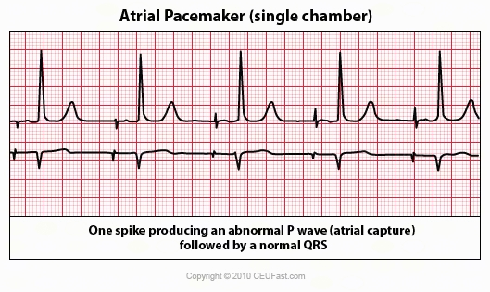

AV Sequential Pacing
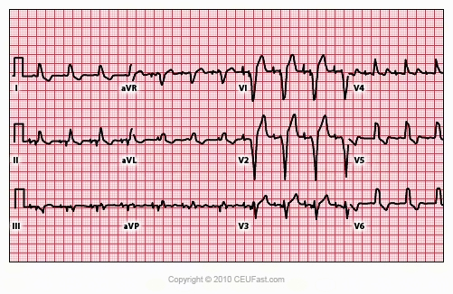

In this ECG both atria and ventricles are being paced. Two pacemaker spikes are seen before each QRS, one for the atria and one for the ventricles (best seen in lead V1).
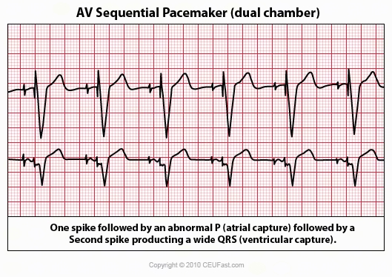

Ventricular Pacing in Atrial Fibrillation
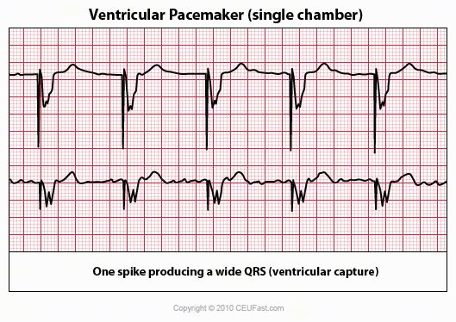

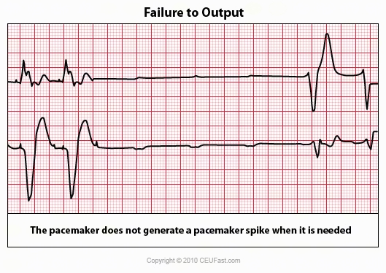

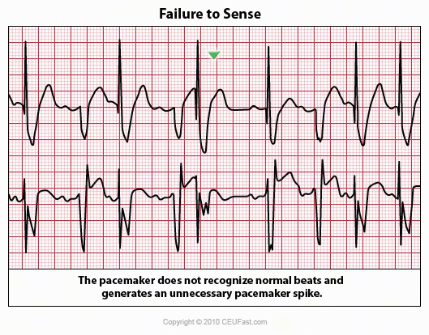

References
American Heart Association Advanced Cardiac Life Support. (2006). CD
ECG Image Index. ECG Learning Center (2008). Retrieved April 16, 2008 from
http://library.med.utah.edu/kw/ecg/image_index/index.html#Sinus
Fussell, D. (2008). Telemetry Study Guide. Lake City VA Medical Media, January 2008.
Grauer, Ken, MD. ACLS: Practice Code Scenarios. (2008). Retrieved April 16, 2008 from ekgpress@mac.com
12 Lead ECG. (2008) Retrieved April 16, 2008 from http://www.sh.lsuhsc.edu/fammed/OutpatientManual/EKG/ecghome.html
Author: Donna Thomas, RN, BSHEd
Donna Thomas, RN, BSHEd, a hospital supervisor with over 37 years of teaching experience, coordinates ACLS, BCLS, AIDS/HIV, Disaster Planning, Leadership, Management, Critical Care classes, former Medical Explorer Leader/Advisor for High School Students and former Water Safety Instructor Trainer for the American Red Cross.

