Sinus Tachycardia
ECG INTERPRETATION: PART II

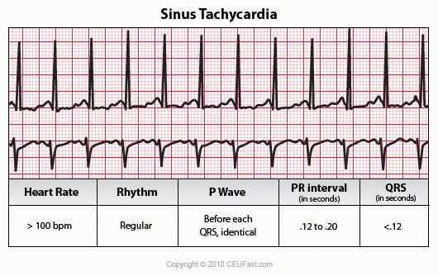

May be the result of stress, exercise, pain, fever, pump failure, hyperthyroidism, drugs-caffeine, nitrates, atropine, epinephrine, and isoproterenol, nicotine
Sinus Arrhythmia
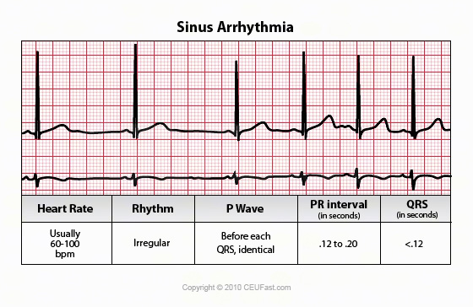

Rate: Usually 60-100 beats/min but may be either faster or slower
Commonly seen in the elderly and the young and usually does not require treatment. Heart rate increases with inspiration and decreases with expiration.
Sinus Arrest or Sinus Pause
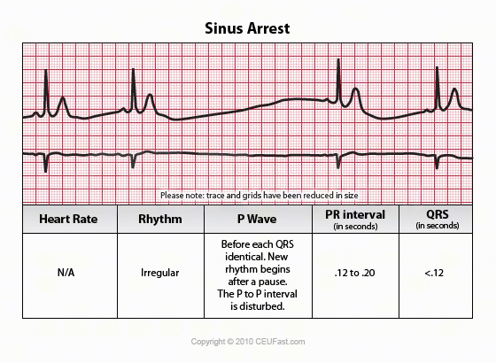

Rate: Usually 60-100 beats/min but may be either faster or slower
Rhythm: Irregular The SA node initiates and impulse, but the impulse is blocked before leaving the node itself. This results in an absent PQRST complex.
In sinus arrest, the pause is not a multiple of other P-P interval and can be due to multiple problems. Treatment may include Atropine or a pacemaker if symptomatic.
Sinus Exit Block (Sinoatrial Block)
Rate: Usually 60-100 beats/min but may be either faster or slower
Rhythm: Irregular The SA node initiates and impulse, but the impulse is blocked before leaving the node itself. This results in an absent PQRST complex. The pause is the same as the distance between two P-P intervals of the underlying rhythm. Uniform and upright in appearance
P waves: One P wave precedes each QRS complex that is present
PRI: .12-.20 sec
QRS: <.10
May be due to: Myocardial Infarction, drug effect, Coronary Artery Disease, etc. Treatment may include Atropine or a pacemaker if symptomatic.
Premature Atrial Complexes (PACs)
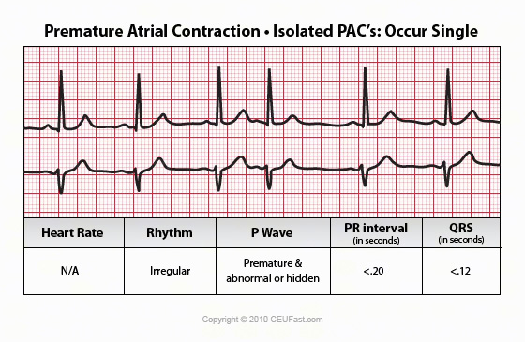

Rate: Usually normal, but depends on underlying rhythm
Rhythm: Irregular due to PACs. Irregular since the impulse occurs early.
Premature beats are identified by their site of origin (atrial, junctional, and ventricular). PAC occurs when an irritable site within the atria discharges before the next SA node is due to discharge.
PAC's with a wide complex are called aberrantly conducted PAC's.
May occur in pairs (couplet), burst (Premature Atrial Tachycardia) PAT, every other beat (bigeminy).
P waves: P wave of the early beat differs from sinus P waves and is premature. P waves may be flattened or notched. May be lost in the preceding T wave.
PRI: Varies from .12- .20 when the pacemaker site is near the SA node, to .12 sec when the pacemaker site is nearer the AV node.
QRS: Usually <.10 but may be prolonged
May be due to normal response to sleep or in well conditioned athlete; Abnormal drops in rate caused by diminished blood blow to S-A node, vagal stimulation, hypothyroidism, increased intracranial pressure, or pharmacologic agents such as digoxin, propranolol, quinidine, or procainamide. May be associated with signs of impaired CO; symptoms: dizziness, syncope, chest pain.
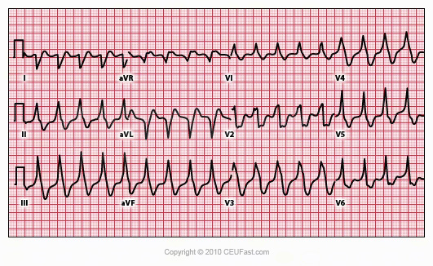

(Lead II )PACs marked by green arrow.

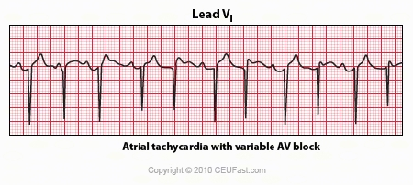

In this rhythm the atrial rate from an ectopic focus is 160 bpm. Atrial activity can be seen on top of T waves, and before QRS's. Careful observation reveals a 3:2 Wenckebach relationship between P waves and QRS's. Atrial tachycardia with block is often a sign of digitalis intoxication.
Supraventricular Tachycardia (SVT, PSVT, PAT, Atrial Tachycardia)
Rate: 150-250/min
Rhythm: Regular
P waves: Atrial P waves differ from sinus P waves originating in the SA node. P waves are usually identifiable when there is a low rate and seldom identifiable at rates >200.
PRI: Usually not measurable because the P wave is difficult to distinguish from the preceding T wave; if measurable, is .12-.20.
QRS: <.10 sec
If an event is documented, usually a PAC that continues into SVT, it is termed PAT.
May be the result of stress, caffeine, nicotine, or heart disease. Treatment consists of oxygen, vagal maneuvers, or possibly adenosine. Unstable patients may receive a counter shock to allow the SA node to recapture.
Wandering Pacemaker
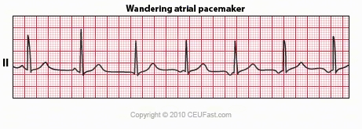

Rate: Could be fast or slow depending upon the cause
Rhythm: Irregular because the stimulus originates in different sites
P waves: May look different in the same lead
QRS: QRS duration is usually normal (0.10 seconds or less)
May be due to COPD, Heart Disease or Digitalis toxicity. Wandering atrial pacemaker is a benign rhythm change where the pacemaker site shifts from the sinus node into the atrial tissues. P-wave morphology varies with the pacemaker site.
Atrial Flutter -12 lead ECG
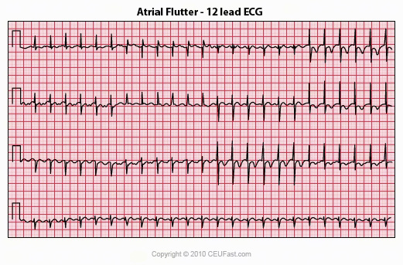

Atrial flutter with 2:1 AV block is one of the most frequently missed ECG rhythm diagnoses because the flutter waves are often hard to find. In this example two flutter waves for each QRS are best seen in lead III and V1. The ventricular rate at 150 bpm should always prompt us to consider atrial flutter with 2:1 conduction as a diagnostic consideration
Rate: Atrial rate 250-350/ min
Rhythm: Atrial rhythm regular, Ventricular rhythm usually regular, but may be irregular. If the AV node blocks the same number of impulses, and only allows a certain amount of impulses to be conducted to the ventricles, the ventricular rate will be constant (such as 3:1 or 4:1).
P waves: Saw-toothed, "flutter waves are buried in the QRS complex
PRI: Not measurable
QRS: Usually <. 10 but may be widened if flutter waves are buried in the QRS complex
May be due to: ischemia, MI valvular disease, hypoxia, or drug effects. If ventricular response is less than 100, and the patient is asymptomatic, the condition is treated medically. If the ventricular response is more than 100, and the patient shows symptoms of heart failure, treatment may consist of countershock.
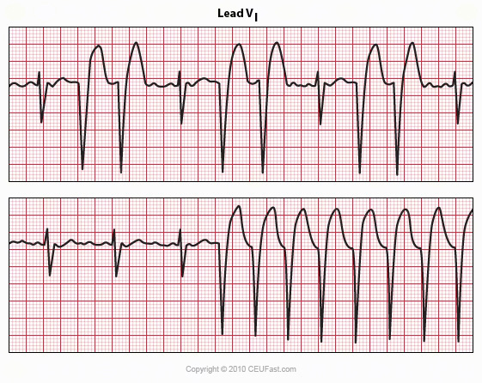

The basic rhythm is atrial flutter with variable AV block. When 2:1 conduction ratios occur there is a rate-dependent LBBB. Do not be fooled by the wide QRS tachycardia on the bottom strip. It is not ventricular tachycardia, but atrial flutter with 2:1 conduction and LBBB. Lidocaine is not needed because there is no ventricular ectopy.
Atrial Fibrillation
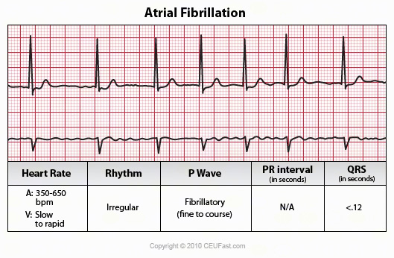

Diagram of Atrial Fibrillation Rate: Atrial rate usually > 400, Ventricular rate variable
Rhythm: Atrial and ventricular very irregular (regular, bradycardic ventricular rhythm may occur as a result of digitalis toxicity)
P waves: No identifiable P waves, Erratic, wavy baseline
PRI: None
QRS: Usually <.10
Rapid impulses originating in multiple sites in the atria cause the atrium itself to "quiver". This is ineffective in allowing for an effective atrial kick. The AV node protects the patient from having too high a ventricular response, and blocks the majority of the impulses.
Blood may pool or stagnate in the atria and the patient is at risk for clot formation.
May be due to: ischemia, Myocardial Infarction hypoxia, or drug therapy. Treatment may consist of beta-blockers (Inderal), calcium blockers (verapamil), or synchronized cardioversion in an attempt to restore the patient to a sinus rhythm.
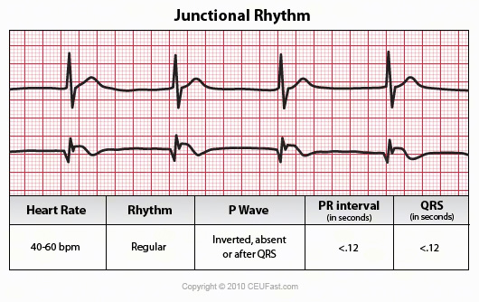

Junctional Bradycardia
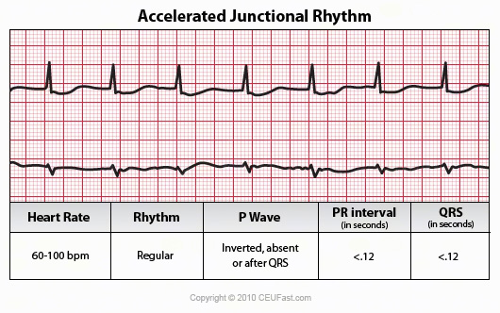

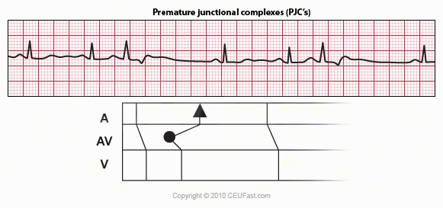

The ladder diagram illustrates the PJC with retrograde atrial capture
Junctional Rhythms
Impulses coming from the Junction (AV node). The inherent rate of the junction is 40-60/min. Characteristics:
Rate: Junctional bradycardia - < 40
Junctional rhythm norm 4 - 60/ min
Accelerated junctional rhythm 61-10
Junctional tachycardia - > 100
Rhythm: regular
P waves: inverted before or after the QRS, or absent
PRI: not measurable if no P wave or if P wave occurs after QRS
QRS: normal
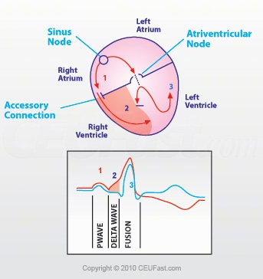

Wolff-Parkinson-White Syndrome (WPW)
The short PR interval is due to a bypass track, also known as the Kent pathway. By bypassing the AV node the PR shortens. The delta wave represents early activation of the ventricles from the bypass tract. The fusion QRS is the result of two activation sequences, one from the bypass tract and one from the AV node. The ST-T changes are secondary to changes in the ventricular activation sequence.
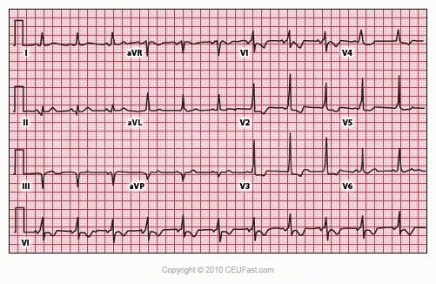

Short PR intervals and delta waves are best seen in leads V1-5. Pseudo-Q waves, seen in leads II, III, and aVF, are actually negative delta waves. There is no inferior MI on this ECG.
Wolff-Parkinson-White Syndrome (WPW) must be seen in more than one lead.
The classical ECG features of the syndrome originally described are a short P-R interval and a broad QRS.
Rate: Usually 60-100 beats/min but may be either faster or slowerWPW may be due to congenital pathways that allow rapid conduction of impulses. May predispose the patient to atrial tachycardia since there is no blocking of impulses at the AV node.
PRI: If this interval is short, it is because the sinus impulse partially avoids its normal delay in the AV node by traveling rapidly down the accessory pathway.
QRS: Often greater than 0.10 seconds since there is no delay in the AV node. Subsequent activation of the ventricles depends upon intra-atrial conduction time from sinus node to the accessory pathway plus conduction time down the accessory pathway, compared with the conduction time from sinus node to ventricles via orthodox conduction pathways.
Delta Wave: Slurring occurs at the beginning of the QRS complex.
Secondary T wave changes: Because ventricular depolarization is abnormal, repolarization will also be abnormal, causing ST and T wave changes secondary to the degree and area of pre-excitation.
Abnormal Q waves: Q waves are considered abnormal when they have an amplitude 25% of the succeeding R wave and /or a duration of 0.04 second or greater. Such Q waves are often seen in the presence of an accessory AV pathway and may be misdiagnosed as Myocardial infarction. They are actually negative delta waves, reflecting pre-excitation and not myocardial necrosis.
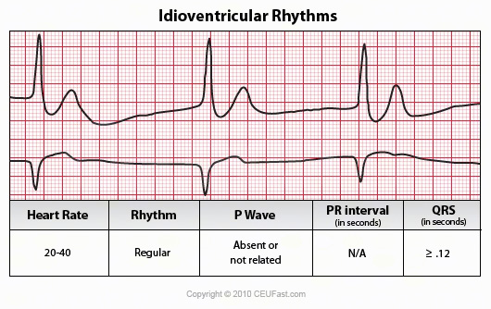

Ventricular Rhythms
Ventricular impulses come from the ventricles.
Inherent rate of ventricles is: 15 -40
Idioventricular Rhythm (IVR) or Ventricular Escape Rhythm
Rate: Intrinsic rate is 20-40 beats per minute
Rhythm: Atrial not discernible, ventricular essentially regular
P waves: absent
PRI: None
QRS: >.12
May be due to: MI, metabolic imbalances, or severe hypoxia. Treatment includes activation of code/890, CPR given if patient is pulseless. Lidocaine is contraindicated since it may knock out the last available pacemaker.
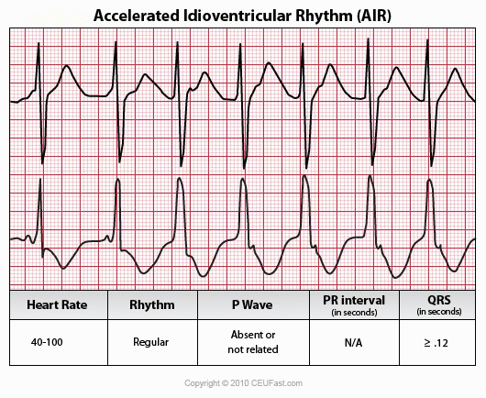

Accelerated Idioventricular Rhythm (AIVR)
Rate: Atrial not discernable, ventricular 40-100 beats/minute
Rhythm: Ventricular rate regular, atrial rate not discernable
P waves: Absent
PRI: None
QRS: > .12
May be due to: Heart disease (e.g., acute myocardial infarction, digitalis toxicity, at reperfusion of a previously occluded coronary artery), may occur During Resuscitation, Drugs (e.g., digoxin), dilated cardiomyopathy, and during Outpatient procedures (due to spinal anesthesia).
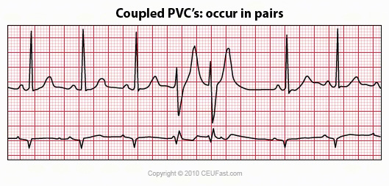

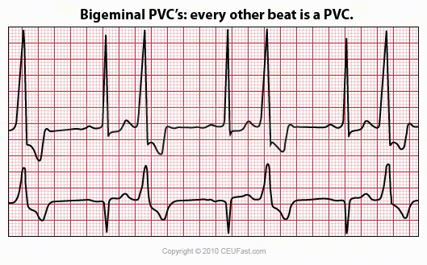

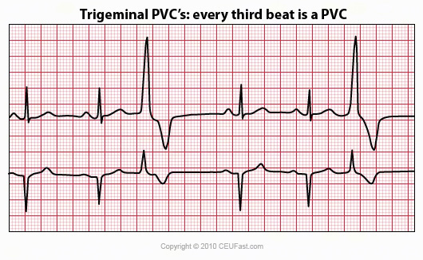

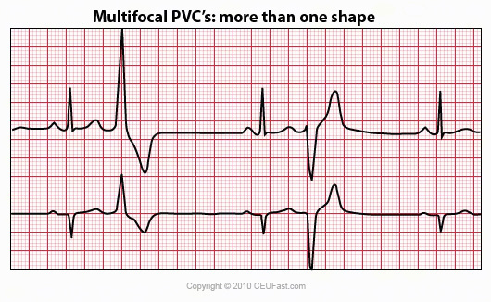

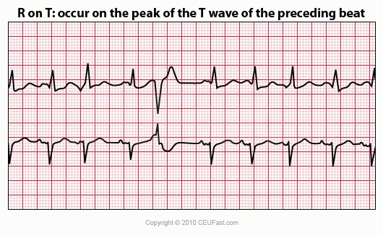

Premature Ventricular Complexes (PVCs)
Rate: Atrial and ventricular rate dependent upon the underlying rhythm
Rhythm: Irregular due to PVC. If PVC is sandwiched between two normal beats it is called interpolated and the rhythm will be regular
P Waves: A P wave is not associated with the PVC
PRI: None with the PVC because the ectopic originates in the ventricles
QRS: .12 Wide and bizarre. T wave frequently in opposite direction of the QRS complex. If the QRS is negative, the T wave is usually upright; if the QRS is positive, the T wave is usually inverted.
May be due to: stress, activity, valvular disease, CAD, or MI. PVC may produce a pulse and the patient should be treated, not the monitor.
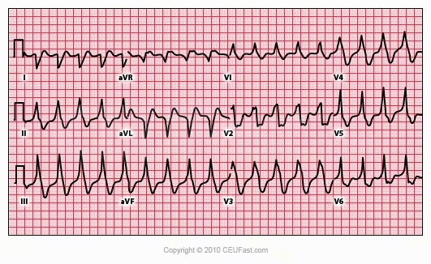

The main feature of this wide QRS tachycardia that indicates its ventricular origin is the concordance of QRS's in the precordial leads (all QRS's are in the same direction).
Ventricular Tachycardia (VT) Monomorphic
Rate: Ventricular rate 100-250 beats/minute, atrial not discernible
Rhythm: Atrial not discernible, ventricular essentially regular
P waves: May or may not be present, if present they have not set relationship to the QRS complexes. P waves may appear between the QRS at a rate different from that of the VT.
PRI: None
QRS: >.12 Often times difficult to differentiate between QRS and T wave.
Three or more PVCs in a row at rate of 100 per minute are referred to as a "run" of VT. There may be a long or a short run. Patient may or may not have a pulse. If it is unclear as to where a regular, wide QRS tachycardia is VT or Supraventricular Tachycardia treat the rhythm as VT until proven otherwise.
Note: Ventricular tachycardia can occur in the absence of apparent heart disease.
May be due to: an early or a late complication of a heart attack, or during the course of cardiomyopathy, alveolar heart disease, myocarditis, and following heart surgery.
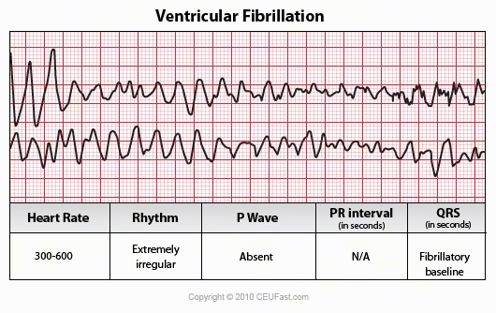

Ventricular Fibrillation (VF)
Rate: rapid and disorganized
Rhythm: irregular and chaotic
P Wave: absent but can be recognizable
PRI: not measurable
QRS: fibrillatory waves; wide irregular oscillations of the baseline.
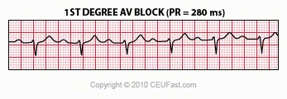

The normal PR interval (PRI) is 0.12 - 0.20 sec, or 120 -to- 200 ms. 1st degree AV block is defined by PR intervals greater than 200 ms. This may be caused by drugs, such as digoxin; excessive vagal tone; ischemia; or intrinsic disease in the AV junction or bundle branch system.
Atrial Ventricular Blocks (AV Blocks)
First Degree:
PRI longer than .20 sec
There is No Block at all just a delay in conduction.
Every P wave is married to a QRS; no missed beats.
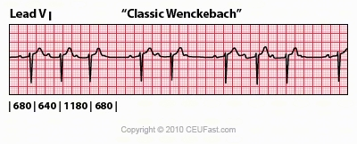

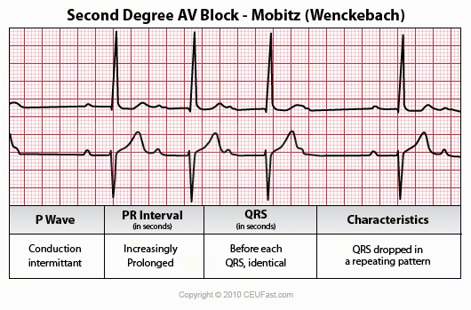

Second Degree:
Type I (Mobitz I or Wenckebach)
The 3 rules of "classic AV Wenckebach" are: 1. decreasing RR intervals until pause; 2. the pause is less than preceding 2 RR intervals; and 3. the RR interval after the pause is greater than the RR interval just prior to pause. There is a gradual and progressive increase in the PR interval (PRI) with successive beat, until finally the QRS is dropped. Unfortunately, there are many examples of atypical forms of Wenckebach where these rules do not hold.
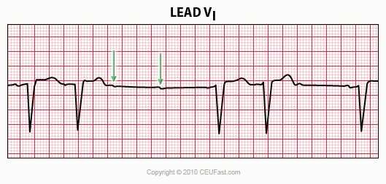

The QRS morphology in lead V1 shows LBBB. The arrows point to two consecutive nonconducted P waves, most likely hung up in the diseased right bundle branch. This is classic Mobitz II 2nd degree AV block.
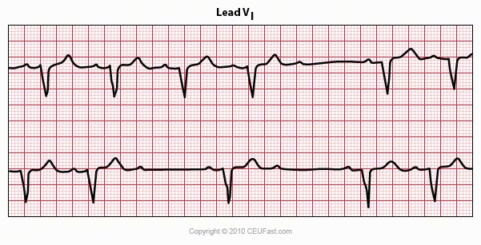

Mobitz II 2nd degree AV block is usually a sign of bilateral bundle branch disease. One of the two bundle branches should be completely blocked; in this example the left bundle is blocked. The nonconducted sinus P waves are most likely blocked in the right bundle which exhibits 2nd degree block.
Type II (Mobitz II)
PRI is fixed (no progressive increase in PRI)
QRS is dropped without warning; there will always be more P Waves than QRS
The P waves are married to the QRS
The level of conduction problem is usually lower than the AV node, often involving the Bundle of His
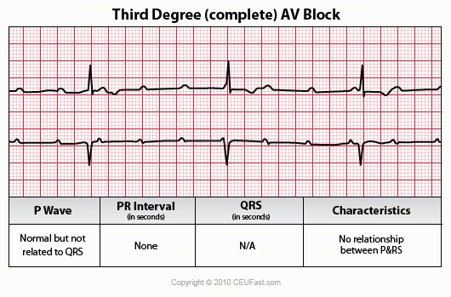

Diagram is Third Degree with Junctional Rhythm
Third Degree (Complete Heart Block)
There is complete heart block so that none of the impulses from above are conducted to the ventricles
The atria and the ventricles are controlled independently by separate pacemakers
P Waves are NOT married to the QRS
The level of the complete block is High, when the AV node takes control of the ventricles. The QRS will therefore be narrow and the junctional rate will be between 40-60.
If the level of the block is Low, a ventricular pacemaker will control the ventricles. The QRS will therefore be wide and the rate is slower.
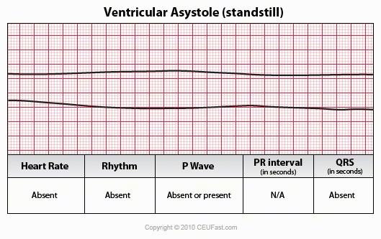

Asystole is synonymous with Ventricular Standstill and death. This is usually associated with prolonged circulatory insufficiency and cardiogenic shock. This could also be drug related and at times reversible.

References
American Heart Association Advanced Cardiac Life Support. (2006). CD
ECG Image Index. ECG Learning Center (2008). Retrieved April 16, 2008 from
http://library.med.utah.edu/kw/ecg/image_index/index.html#Sinus
Fussell, D. (2008). Telemetry Study Guide. Lake City VA Medical Media, January 2008.
Grauer, Ken, MD. ACLS: Practice Code Scenarios. (2008). Retrieved April 16, 2008 from ekgpress@mac.com
12 Lead ECG. (2008) Retrieved April 16, 2008 from http://www.sh.lsuhsc.edu/fammed/OutpatientManual/EKG/ecghome.html
Author: Donna Thomas, RN, BSHEd
Donna Thomas, RN, BSHEd, a hospital supervisor with over 37 years of teaching experience, coordinates ACLS, BCLS, AIDS/HIV, Disaster Planning, Leadership, Management, Critical Care classes, former Medical Explorer Leader/Advisor for High School Students and former Water Safety Instructor Trainer for the American Red Cross.

